6.1 Uniform Quantization and Quantization Error Analysis of a Discrete-Time Sinusoidal Signal Using MATLAB

CODING:
clc;
clear;
close all;

%% Signal
fs = 1000; % Sampling frequency
f = 50; % Signal frequency
t = 0:1/fs:0.1; % Time vector
x = sin(2*pi*f*t); % Original sine wave

%% Quantization Levels
L = [8 16 32];
colors = {'r','g','m'};

% Preallocate
xq = cell(1,length(L));
e = cell(1,length(L));
mse = zeros(1,length(L));

%% Plot Original and Quantized Signals
figure;

% Original Signal
subplot(4,1,1);
plot(t,x,'b','LineWidth',1.5);
title('Original Signal');
xlabel('Time (s)');
ylabel('Amplitude');
grid on;

for i = 1:length(L)

% Quantization
xq{i} = round(((x + 1) .* (L(i)-1)) ./ 2);

% Convert back to signal range [-1,1]
xq{i} = (xq{i} .* 2 ./ (L(i)-1)) - 1;

% Quantization Error
e{i} = x - xq{i};

% Mean Square Error
mse(i) = mean(e{i}.^2);

% Plot Quantized Signal
subplot(4,1,i+1);
stairs(t,xq{i},colors{i},'LineWidth',1.2);
title(['Quantized Signal (' num2str(L(i)) ' Levels)']);
xlabel('Time (s)');
ylabel('Amplitude');
grid on;
end

%% Display MSE
fprintf('\nMean Square Error (MSE):\n');
fprintf('MSE for 8 Levels = %.6f\n', mse(1));
fprintf('MSE for 16 Levels = %.6f\n', mse(2));
fprintf('MSE for 32 Levels = %.6f\n', mse(3));

%% Error Plots
figure;

for i = 1:length(L)
subplot(3,1,i);
plot(t,e{i},'LineWidth',1.2);
title(['Quantization Error (' num2str(L(i)) ' Levels)']);
xlabel('Time (s)');
ylabel('Error');
grid on;
end

OUTPUT:
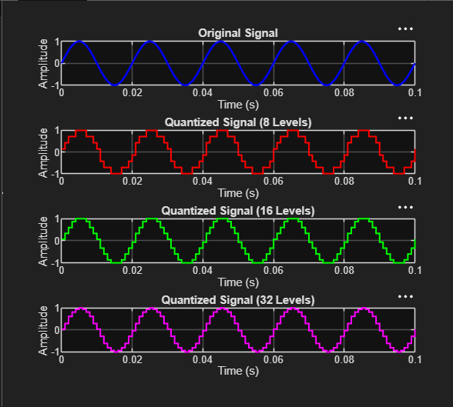

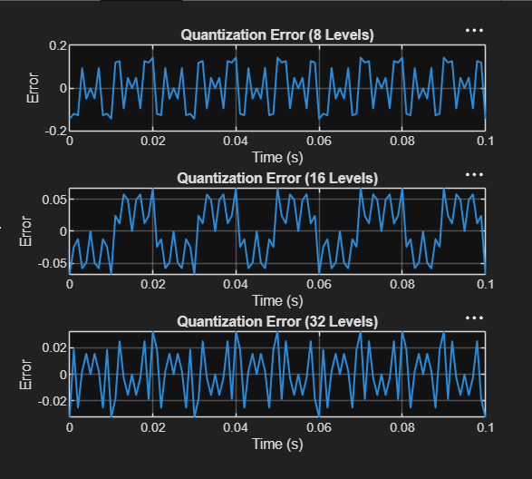

RESULT:
Mean Square Error (MSE):
MSE for 8 Levels = 0.010473
MSE for 16 Levels = 0.001763
MSE for 32 Levels = 0.000357
>>

